Showcasing e-Assessment Opportunities Worldwide

The take up of e-Assessment is increasing world-wide. Educators, trainers, Government Agencies and test providers are actively engaged in developing technology based assessment solutions that enable them to provide reliable, flexible assessment for students and employees.  Assessment Tomorrow is one of the leading international organisers of conferences and seminars in the field of e-Assessment as well as being a leading adviser to education, industry and government on the selection and introduction of e-Assessment. Drawing on expertise from the UK, Europe and worldwide, it organises conferences and seminars aimed at providing policy makers, assessment developers and people implementing e-Assessment in schools, colleges and training providers with the opportunity to debate the issues and find out about the latest developments.  To date, events have been run in London, Manchester, Birmingham, Glasgow, Dublin, Edinburgh, Kuala Lumpur, Bangalore, Hong Kong, Kolkata and Bangkok. Between 2009 and 2012, further events are being planned in Europe, Africa and Asia. Each conference has its own theme, aimed at a particular aspect of the educational market or the development needs of the region. Example programmes and other details from our conferences are available from the website  www.assessmenttomorrow.com  The conferences provide opportunities for e-Assessment and e-learning organisations to sponsor and exhibit as well as provide speakers with the opportunity to present to audiences which include key purchasers and users of assessment systems. Assessment Tomorrow have also held a series of seminars for individual organisations such as Government agencies, and universities to showcase how e-Assessment, the use of IT to measure skills, knowledge and understanding, can support learning and skills development and provide a robust and reliable method for measuring and developing the talent pool..  Working with experienced professionals, Assessment Tomorrow can provide e-Assessment project consultancy with an admirable track record of achievement. We can access a range of services including assessment design, assessment delivery systems, design services and system evaluation. | 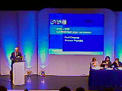  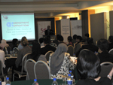  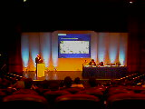  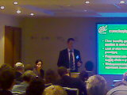  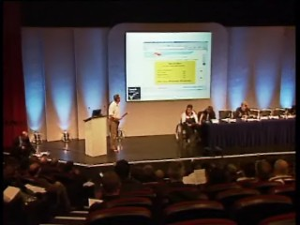

The Team/Conference Directors | 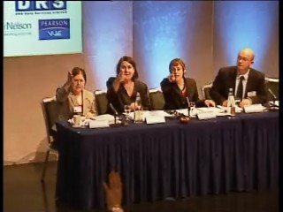  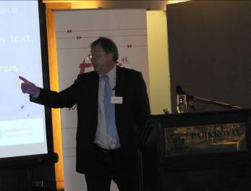        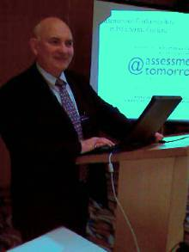
Martyn Roads is an independent education and assessment consultant. He spent 13 years in Further Education, developing and managing a wide range of vocational programmes before joining BTEC in 1994. In 2001, he was responsible for managing, on behalf of a consortium of Awarding Bodies, the successful bid for the development of the current Key Skills and Skills for Life National Tests. For the past 4 years, Martyn has been researching and implementing the use of IT in assessment which has included working with a consortium of organisations on the development of a range of screening and initial assessment tools for the SfLSU. Martyn was co-author of QCA’s “Use of ICT in Assessment” report to the DfES in 2002 and is currently working with QCA on a number of projects including supporting the production of the e-Assessment – Effective Practice Guide. Martyn is also Chair of Becta’s e-assessment advisory group. The last seven years has seen joint responsibility for many successful conferences, seminars and events across the globe focused on Skills Development and the use of IT in education and training.

Jeff Ross is an Independent Prince II project manager and consultant supporting clients managing the development and introduction of IT systems to meet business and administrative needs. His fields of expertise include e-Assessment, e-learning and the use of IT and internet technologies in the education, training and human development fields. Previously he was a senior manager with a major awarding body, where he was responsible for change management programmes associated with the introduction of ICT solutions to the delivery of education services and qualifications. His background is in IT, education, publishing, logistics and business operations. The last seven years has seen joint responsibility for many successful conferences, seminars and events across the globe focused on Skills Development and the use of IT in education and training.


……………………… ………………………
Jeff Ross Martyn Roads
07785 92 03 92 0780 272 4750
jeff@assessmenttomorrow.com martyn@assessmenttomorrow.com

Assessment Tomorrow Ltd :Registered in Cardiff No 5534467
Registered Office: 5 St Catherine’s Road Broxbourne EN10 7LG ENGLAND UK

